1. **Get All User Activty Details**

This API is used for retrieving all activity details from the database.

* **URL**

/activityDetails/all

* **Method:**

GET

* **URL Params**

Not required

* **Data Params**

Not required

* **Success Response:**

Example:

* **Code:** 200

**Content:** [{"beginDate":"2019-04-16","endDate":"2019-04-16","location":"Sarajevooo","activityId":1,"id":1},{"beginDate":"2019-04-16","endDate":"2019-04-16","location":"Sarajevo","activityId":2,"id":2},{"beginDate":"2019-04-16","endDate":"2019-04-16","location":"Sarajevo","activityId":3,"id":3},{"beginDate":"2019-04-16","endDate":"2019-04-16","location":"Sarajevo","activityId":4,"id":4},{"beginDate":"2019-04-16","endDate":"2019-04-16","location":"Sarajevo","activityId":6,"id":5}]

* **Sample Call:**

$.ajax({

url: "/activityDetails/all",

dataType: "json",

type : "GET",

success : function(r) {

console.log(r);

}

});

* **Notes:**

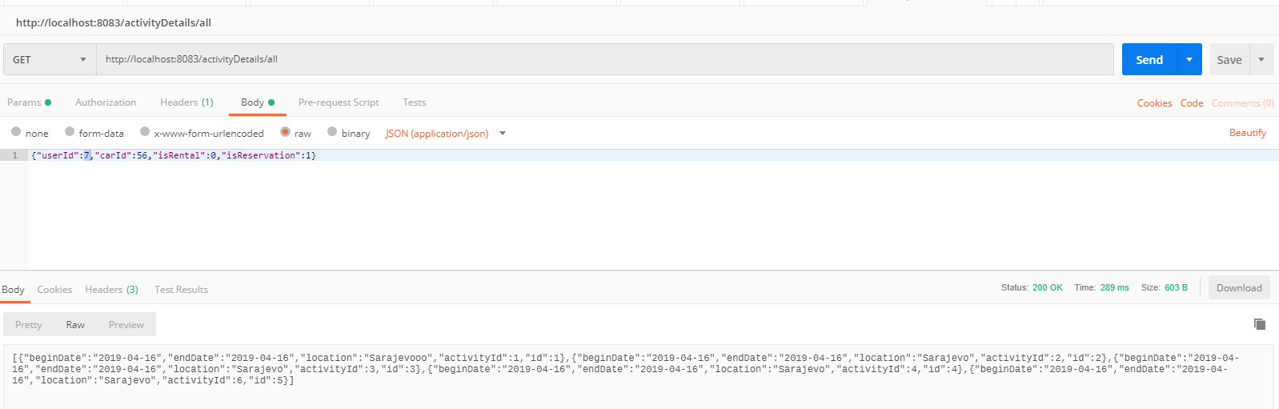

Image 1: Screenshot for GetAllActivityDetails

1. **Get Activity Detail By ID**

Retrieve the user activity detail with specific ID

* **URL**

activityDetails/activities/:id

* **Method:**

GET

* **URL Params**

**Required:**

id=[Long]

* **Data Params**

Not required

* **Success Response:**
* **Code:** 200   
  **Content:**

{"beginDate":"2019-04-16","endDate":"2019-04-16","location":"Sarajevooo","activityId":1,"id":1}

* **Sample Call:**

$.ajax({

url: "activity/activities/{id}",

dataType: "json",

type : "GET",

success : function(r) {

console.log(r);

}

});

* **Notes:**

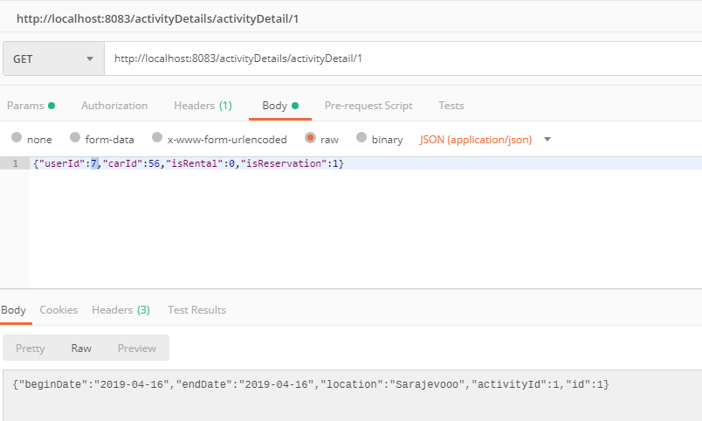

Image 2: Screenshot for GetActivityDetailById

1. **Add New Activity Detail**

Create new user activity

* **URL**

activitiyDetails/addDetail

* **Method:**

POST

* **URL Params**

id=[Long]

* **Data Params**

Not required

* **Success Response:**
* **Code:** 200   
  **Content:** {

{"beginDate":"2019-04-16T00:00:00.000+0000","endDate":"2019-04-16T00:00:00.000+0000","location":"Sarajevooo","activityId":23,"id":6}

}

* **Sample Call:**

$.ajax({

url: "/activityDetails/addDetail",

dataType: "json",

type : "POST",

success : function(r) {

console.log(r);

}

});

* **Notes:**

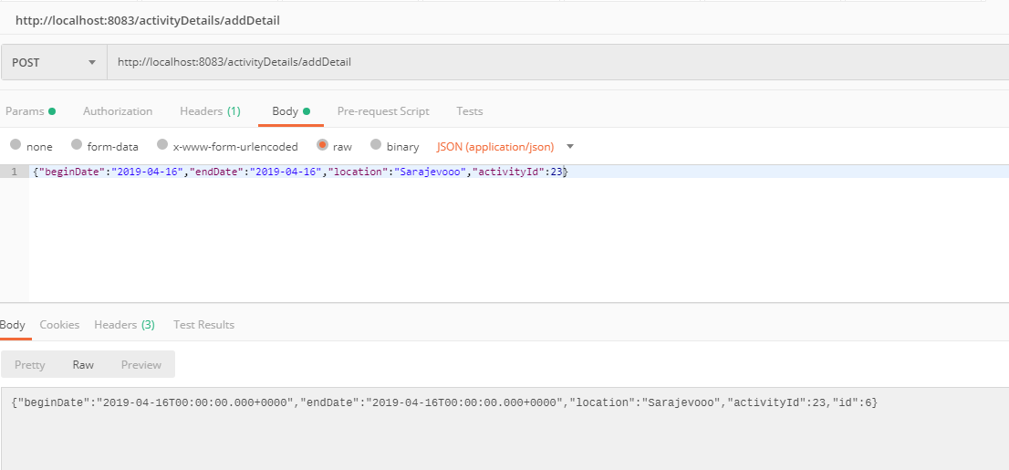

Image 3: Screenshot for AddNewActivityDetail

1. **Delete Activity**

Delete user activity from the database

* **URL**

/activityDetails/removeActivity/:id

* **Method:**

DELETE

* **URL Params**

id=[Long]

* **Data Params**
* **Success Response:**
  + **Code:** 200   
    **Content:** Activity Detail with id:{id} was deleted!
* **Error Response:**

Will be added in future

* + **Status:** 404 Not Found   
    **Content:** { Unable to remove. Activity detail with id:{id} not found. }
* **Sample Call:**

$.ajax({

url: "/activityDetails/removeActivityDetail/{id}",

dataType: "json",

type : "DELETE",

success : function(r) {

console.log(r)

}

});

* **Notes:**

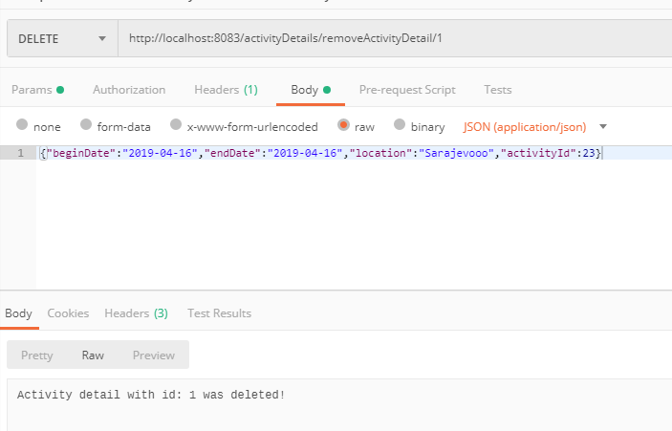

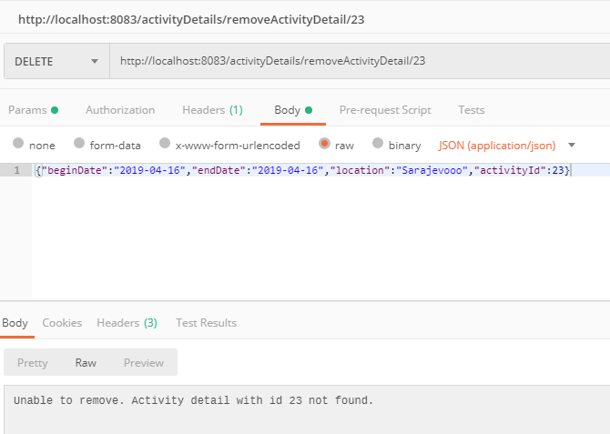

Image 4: Screenshot DeleteUserActivityDetail

1. **Update Activity**

Update user activity detail from the database

* **URL**

/activityDetails/update/:id

* **Method:**

PUT

* **URL Params**

id=[Long]

* **Data Params**
* **Success Response:**

**Code:** 200   
**Content:** {"beginDate":"2019-04-16T00:00:00.000+0000","endDate":"2019-04-16T00:00:00.000+0000","location":"Bec","activityId":24,"id":3}

* **Error Response:**

**Code:** 404

**Content:** Unable to update. Activity detail with id 2 not found.

* **Sample Call:**

$.ajax({

url: "/activityDetails/update/{id}",

dataType: "json",

type : "PUT",

success : function(r) {

console.log(r)

}

});

* **Notes:**

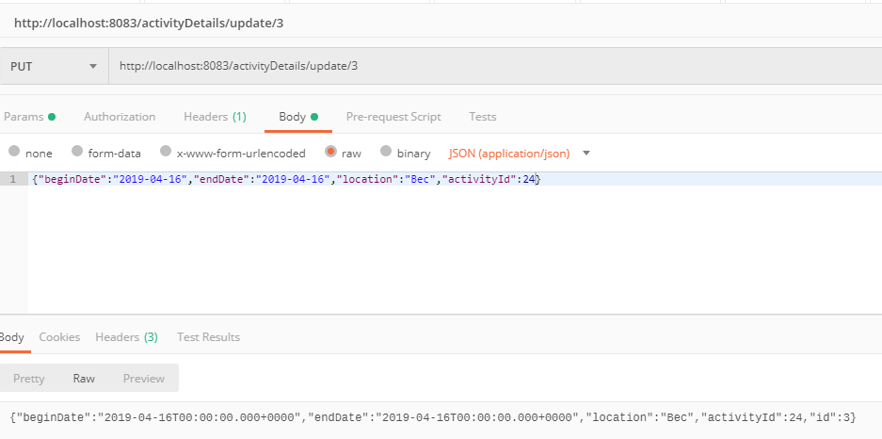

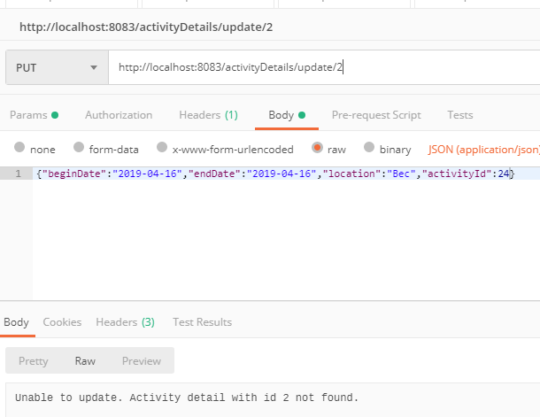

Image 5: Screenshot UpdateUserActivityDetail